2.4 Qualitative Behavior of Equations
Often one would like to know the qualitative behavior of the solution of a differential equation. Qualitative behavior includes things like
1. Is the solution increasing or decreasing or some of each?
2. Is the solution periodic and, if so, what is the period?
2. What happens to the solution for large t?
These are questions related to the gross appearance of the graph of the solution. Questions like these can be answered by solving the equation and getting this information directly from the solution and its graph. However, for some equations one can get this information without solving the equation. In this section, we see how this is done for equations of the form
(1) = g(x)
(2) x = x₀ when t = t₀
where
t = time
x = x(t) = something which varies with time
g(x) = some given function
We illustrate the technique using one of the examples we used for solving separable equations
Example 1. Without actually solving the following equation and initial condition, find the qualitative behavior of the solution of
(3) = 2N - N²
(4) N = 10 when t = 0
In other words, sketch the graph of the solution.
Recall, in that example N = N(t) is the number of mosquitoes in a certain area at time t. Comparing (2) with (1) we see that in (2) one has x = N and g(N) = 2N - N².
In order to determine the qualitative behavior of an equation of the form (1) you do the following steps.
Step 1. Find the equilibrium solutions
An equilibrium solution (or steady state solution) is one that is constant in time. For the equation (1) it is a solution of the form x(t) ≡ C where C where C is a constant. Note that for an equilibrium solution one has . If we plug x(t) ≡ C and use the fact that we get
(5) g(C) = 0
The solutions of this equation are called the equilibrium values. Thus equilibrium solutions correspond to solutions of the equation (5). For each solution C to (5) one obtains an equilibrium solution x(t) ≡ C. There may be one, more than one or no solutions to (5) and hence there may be one, more than one or no equilibrium solutions.
Equilibrium solutions usually don’t satisfy the initial conditions (2), so they usually don’t provide the solution to the initial value problem (1) – (2). However, equilibrium solutions have a strong affect on the other solutions. Often a non-equilibrium solution approaches an equilibrium solution as time gets large.
In nature, equilibrium solutions correspond to situations where some physical system is in equilibrium, i.e. not changing in time. For example, in chemistry, we may mix some chemicals together. At the beginning they are reacting and the system is changing with time. However, after a while the reaction is essentially over and the system is essentially at equilibrium. The law of mass action often allows one to calculate the concentrations of the chemicals at equilibrium.
For the differential equation (3) the equilibrium solutions are of the form x(t) ≡ C where C is a solution to
2C - C² = 0
C(2 – C) = 0
C = 0 or 2 – C = 0
The solution of the second equation is C = 2 or C = 20. So C = 0 and C = 20 are the two equilibrium values and N(t) ≡ 0 and N(t) ≡ 20 are the two equilibrium solutions. Note that neither one satisfies the initial condition (4), so we are not done.
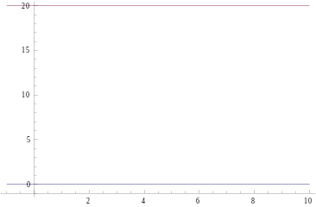
The equilibrium solutions are easy to graph. Their graphs are just horizontal lines through the equilibrium values on the vertical axis. At the right are the graphs of the equilibrium solutions N(t) ≡ 0 and N(t) ≡ 20 in Example 1.
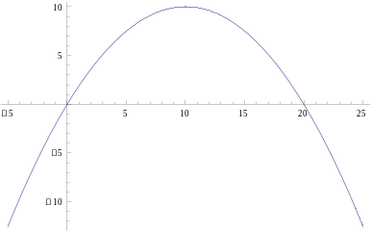
Step 2. Find where the right hand side of the equation g(x) is positive and negative. Let R = g(x) be the equation of the right hand side of the equation. In our example the right hand side of the equation is g(N) = 2N - N², so R = 2N - N². For the moment forget that N depends on t and treat N as an independent variable. We want to determine the values of N for which N is positive and negative. In Step 1 we found the values of N for which R = 0. These are the equilibrium values. Now we want to determine the sign of R in the intervals between the equilibrium values. There are several ways to do this. In the case of R = 2N - N² the variable R is a quadratic function of N with the coefficient of N² negative, so the graph is a parabola opening down. So R is positive between the equilibrium values, i.e. for 0 < N < 20. And negative to the to the left of the left equilibrium value and to the right of the right equilibrium value, i.e. for N < 0 and N > 20. At the right is the graph of R vs N. To summarize, R is positive for N between 0 and 20 and R is negative for N less than 0 and N greater than 20.
Another way to determine the sign in the intervals between the equilibrium values is to pick a value of N in each interval and calculate the sign of R. Another way is to evaluate dR/dN at each equilibrium value. If dR/dN is positive at an equilibrium value then R is positive in the interval to the right of the equilibrium value and negative to the left of the equilibrium value. If dR/dN is negative at an equilibrium value then the situation is just the opposite, i.e. R is negative in the interval to the right of the equilibrium value and positive to the left of the equilibrium value.

Problem 1 For each of the following differential equations, (a) sketch the phase line, (b) identify the equilibrium points, (c) classify the equlibrium points as sinks or sources (d) sketch a few solutions showing their behavior as t → ± ∞.
a. y’ + y² – 1 = 0 Answer: y = 1 is a sink and y = -1 is a source
b. y’ = y (y² – 2y – 8) Answer: y = 0 is a sink and y = 4 and y = -2 are sources
Problem 2 For each of the following differential equations use the phase line to predict the behavior of the solution satisfying the given initial condition as t → ∞.
a. y’ = y² – 7y + 10, y(0) = 3 Answer: y(t) → 2.
b. y’ = y (y² – 2y – 8), y(0) = -1 Answer: y(t) → 0.

